FCH3 -

Functionality
The checks can be voided both before and after they have been printed. The transaction shows you how to void blank checks before posting a payment.

Scenario
One of the check forms was accidentally damaged before being used by SAP system for payment. You need to void this check.

Requirements
The relevant check lot must be maintained in the system.

Menu Path | Accounting → Financial Accounting → Accounts Payable → Environment → Check information → Void → FCH3 - Unused checks
Transaction Code | FCH3

1. Double click on FCH3 - Unused checks.

Void Checks Not Used

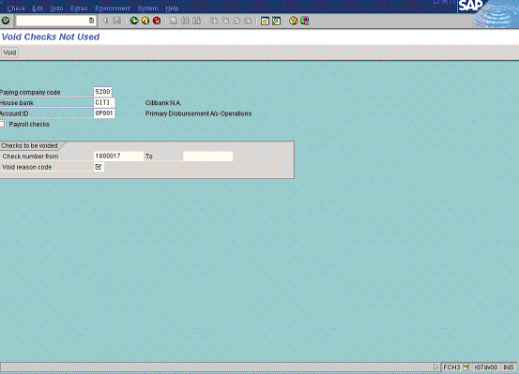

2. Update the following fields:

Field Name | Field Description | Values
Paying company code | The company code which processes the payment transactions | Example: 5200
House bank | Identification number for the house bank to which the transaction corresponds | Example: CITI
Account ID | Bank account ID | Example: OP001
Check number from | The check you want to void | Example: 1000017

3. Press [F4] or click the button in the Void reason code field

Check void reason code (2) 11 Entries found

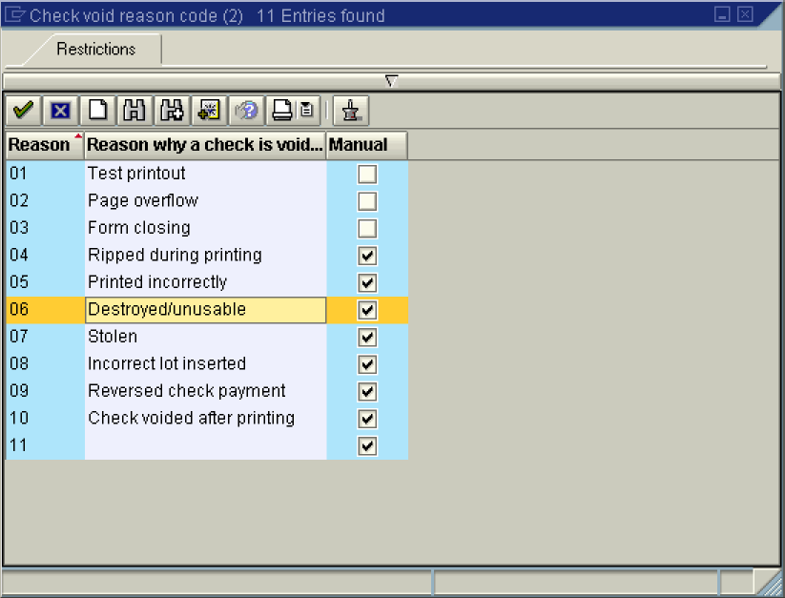

4. Select 06 - Destroyed/unusable in list box.

Void Checks Not Used

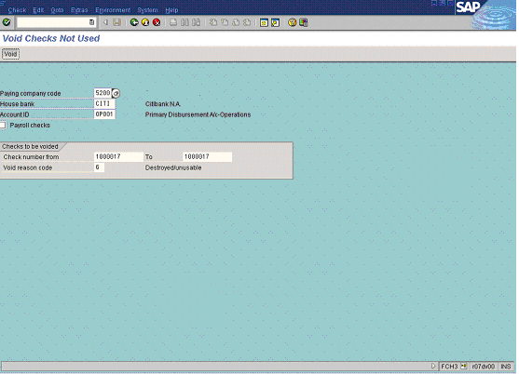

5. Click Enter Button to confirm your entries.

6. To void the check, click Void Button .

